August 2012 | Nova Southeastern University written by Jennifer Corrigan
URL:
http://jennifermcorriganedd.weebly.com

Tech Times

10 Guiding Principles of Instructional Technology and Distance Education
Contents
10 Guiding Principles of ITDE
Principle 1 1
Principle 2 2
Principle 3 3
Principle 4 4
Principle 5 5
Principle 6 6
Principle 7 7
Principle 8 8
Principle 9 9
Principle 10 10
Students in today’s society have been raised on computers, video games, social networking sites, cell phones, as well as many other forms of technology that have shaped the methods in which they process information and are a way of life for 21st century learners.

This news article was designed to provide what I believe to be the most important 10 guiding principles of instructional technology and distance education. Below you will find the principles, literature that supports the principles, as well as graphics and images that depict each principle.

1
Distinguish between media and technology  Confusion sometimes occurs between media and technology. According to Smaldino, Lowther, & Russell (2012), media are  “Means of communication…anything that carries information  from a source to a receiver” such as text, audio, visuals, video, objects and people.  Clark (2001) states that technology is, “the physical, mechanical, or electronic capabilities of a medium that determine its function such as a television, radio, iPods, iPads, computers, cell phones, video cameras, digital cameras and a Smart board. | Principle 1
 | Principle 2
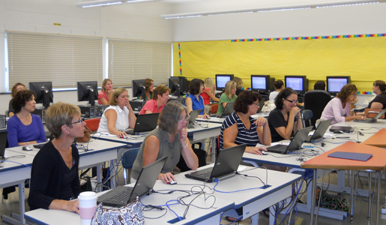
Properly train educators to utilize technology in meaningful ways

Continued professional development catered toward effective integration of technology is imperative for educators to remain technologically advanced. Engagement in professional development will aid in teachers sustaining or improving their technology skills in the classroom.

2

3
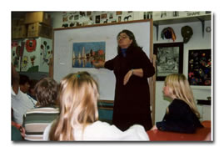

Principle 3
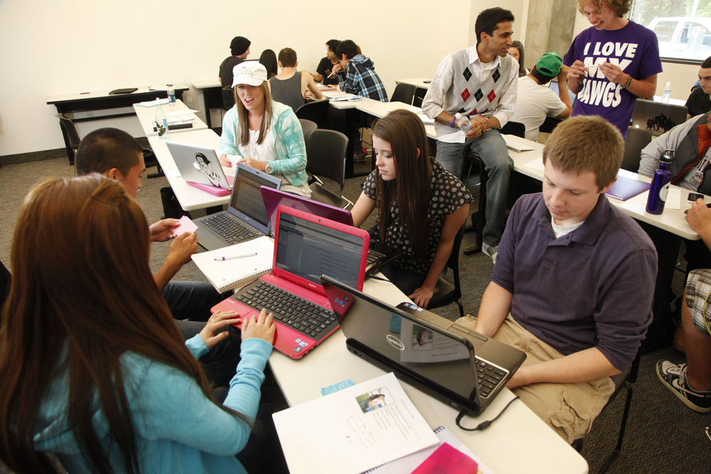

Shift from teacher-centered instruction to more student-centered instruction

Students are not learning the way they used to. It is essential that we steer away from solely teacher-centered instruction.

Student-centered instruction puts responsibility on the students to take ownership of their learning. Student-centered teaching allows for educators to facilitate the learning activities taking place in the classroom. Student-focused academic environments permit teachers to provide individualized instruction and attention to the students.

4
Principle 8

Our students are bored! Do not be afraid to “disrupt” instruction with technology.  By “disrupting” instruction I am referring to a positive alteration of the way we are teaching and presenting information to our students by changing how, when, and where we integrate technology into our instruction. Pedagogical methods of instruction have changed very  little over the past 100 years, while our students and the ways in which they learn are changing dramatically (Wehrli, 2009).  Familiarize yourself with your learners  Smaldino et.al (2012) claims that, “teachers need to understand the characteristics of their students in order to prepare quality learning experiences for them.” In addition to student characteristics, teachers must also grasp their student’s prior knowledge and learning styles. | Principle 4
 | Principle 5
5
6
Encourage and model effective communication

Rashid (2011) asserts that communication is, “the process by which human beings send and receive messages and involves three types- listening, observing, and reading.” Educators have
access to many resources to keep an open line of communication with parents and students (class websites, email, and phone) (Smaldino, Lowther, & Russell, 2012).

Principle 6

Principle 7

7

Principle 8

Principle 8

Provide specific learning objectives
In order to provide direction for your students and to establish student goals, appropriate student learning objectives must be put forth and must coincide with curriculum and technology standards within the academic institution. The learning objectives will clearly demonstrate what students will be able to do at the termination of each lesson.

Educate students on practical ways to manage their time

In order to manage your time wisely it is important to stay organized, start with small goals, reach out for help when needed, and lastly, find a balance between school, work, and home.

Match the most appropriate medium to each teaching strategy

The availability of media, types of learners, the proposed student learning objectives and class size must be taken into consideration when selecting media to utilize in the classroom. The various learning styles of the students also play a vital role in media selection.

Principle 9

Principle 10
Recognize that we are teaching digital students’

Wehrli (2009) proclaims, “Educators can continue to be enforcers, battling with children over their mobile devices, or use the energy inherent in the disruption to revitalize education.”

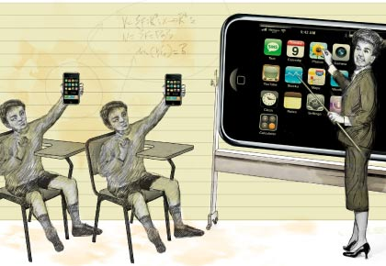

References

Christie, Mark. n.d. Time Management. [Image]. Retrieved on July 18, 2012 from http://www.smartcharacterchoices.com/site/curriculum.asp?id=7

Clark, R. E. (Ed.). (2001). Learning from media: Arguments, analysis, and evidence. (185). Greenwich, CT: Information Age.

Feildman, Dan. n.d. Digital Camera. [Image]. Retrieved on July 18, 2012 from http://newenglandmoments.wordpress.com/photography-features/basic-photography-compact-digital-cameras/
Gerace, W. J., Dufresne, R. J., & Leonard, W. J. (1999). Using technology to implement active learning in large classes. technical report. Retrieved from http://search.proquest.com.ezproxylocal.library.nova.edu/docview/62182975?accountid=6579

Lei, J. (2009). Digital natives as preservice teachers: What technology preparation is needed? Journal of Computing in Teacher Education, 25(3), 87-97. Retrieved from http://search.proquest.com.ezproxylocal.library.nova.edu/docview/61798690?accountid=6579; http://www.iste.org/Content/NavigationMenu/Membership/SIGs/SIGTETeacherEducators/JCTE/PastIssues/Volume25/Number3Spring2009

Rashid, N., & Rashid, M. (2011). Issues and problems in distance education. Turkish Online Journal of Distance Education, 12(4), 108-114. Retrieved from http://search.proquest.com.ezproxylocal.library.nova.edu/docview/1018478890?accountid=6579

Smaldino, S. E., Lowther, D. L., & Russell, J. D. (2012). Instructional technology and media for learning (10 ed. pp. 4-5, 8-10, 38-47, 64, 72, 90-91, 117-118, 284-285, 290). Boston, MA: Pearson.

Warner, Jamillah. December 30, 2011. Confusion. [Image]. Retrieved on July 18, 2012 from http://smallbiztrends.com/2011/12/profile-your-way-to-clarity.html

Wehrli, B. (2009). Technology as a fence and a bridge. Horace, 25(1), 4. Retrieved from http://search.proquest.com.ezproxylocal.library.nova.edu/docview/61831640?accountid=6579

7 Effective time management techniques [Video file]. (2010, February 22). Retrieved from
http://www.youtube.com/watch?v=rM1A9zFkfHw

Bored Students. [Image}. n.d. Retrieved on July 18, 2012 from http://www.presentermedia.com/index.php?target=closeup&maincat=clipart&id=3276

Students Using Technologies, [Image]. November 4-6, 2012. Retrieved on August 2, 2012, from http://www.k12techsummit.com/2012/07/452/

Teacher-Centered Instruction. [Image]. 2001-2003. Retrieved August 2, 2012, from http://paraelink.org/91mrw92mrw/c91mrw92mrw_1.html

Teacher Shaking Student’s Hand. [Image]. n.d. Retrieved on July 18, 2012, from http://www.smartcharacterchoices.com/site/curriculum.asp?id=7

Technology. [Image]. September 14, 2010. Retrieved on July 18, 2012, from http://www.robertbernhardt.com/church-technology.html

Technology and Distance Education. [Image]. August 16, 2011. Retrieved on August 2, 2012, from http://www.vdh.state.va.us/distancelearning/

